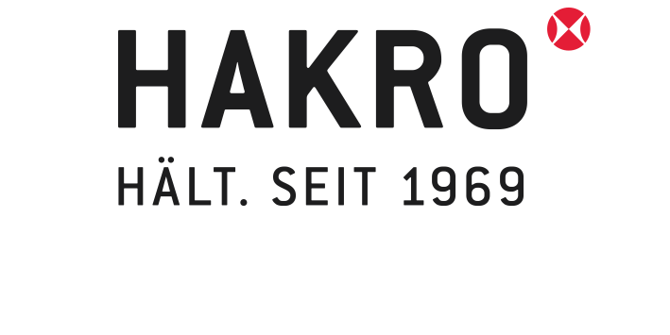
PRESS RELEASE

HAKRO en route to a circular economy
The medium-sized textile company achieves the Cradle to Cradle Certified® standard for 14 models in its NOS collection.

SCHROZBERG, FEBRUARY 2023
- Cradle to Cradle Certified® (C2C) is a product standard based on the circular economy principle.
- Corporate wear supplier HAKRO achieved the Bronze certification level from the Cradle to Cradle Products Innovation Institute (C2CPII) for 14 T-shirts and polo shirts.
- The C2C Certified® standard covers the entire model range of textiles made from 100% cotton by HAKRO’s production partner in Bangladesh.
- HAKRO GmbH is planning to obtain the C2C Certified® standard in more locations and for other products.
The global “Cradle to Cradle Certified®” standard is awarded by the Cradle to Cradle Products Innovation Institute (C2CPII), a non-profit organisation which works to advance the circular economy and guarantee safe products. In its certification process the Institute assesses materials and products in reference to five categories: material health, material cycle, renewable energies, water management and social responsibility. The standard is awarded according to strict criteria and based on the levels Bronze, Silver, Gold and Platinum. The levels reflect both the quality of the individual elements of a product as well as the depth of the data collection.

Corporate wear supplier HAKRO GmbH achieved the Bronze certification level at the first attempt with 14 polo shirts and 100% cotton T-shirts made by their partner company in Bangladesh. “By 2030 we want to be the leading provider for integrated sustainable corporate wear,” says Carmen Kroll, second-generation manager of the medium-sized company with 200 employees. “After we made our entire collection climate neutral at the start of 2022, achieving the C2C standard for our cotton products from Bangladesh was the next milestone in our sustainable business strategy.“ She considers the first C2C certification process as a pilot project and already has her eye on the widescale expansion of C2C standards for HAKRO.

Antonia Hammel, in charge of C2C Certified® standards at HAKRO: “A C2C certification is a very demanding and complex process in all respects. To achieve Bronze status with 14 products at the same time is a huge success, but it’s just the beginning for HAKRO. True to our high standards in sustainability we want to have our range from other manufacturing locations certified too.”

On the decision to start the first certification process for HAKRO T-shirts and polo shirts from Bangladesh, project manager Antonia Hammel from Team Purchasing, Quality and Development said the following: “Our long-standing production partner in Bangladesh runs a vertically integrated operation that combines multiple production levels in one location, which meant we could collect all the data we needed for the certification from a single source.”

Implementing a real circular economy still remains a challenge in many areas, including in the textile industry. While the Cradle to Cradle Certified® standard guarantees the product circularity of textiles and thus their suitability for closed material cycles, the certificate alone is not enough to make this a reality. “Completely transferring material product circularity into a real circular system requires more than corporate commitment. A suitable sector infrastructure is currently lacking in Germany. But HAKRO has staying power and we are working closely with likeminded competitors, pioneers, NGOs and community solution providers in order to reach this goal,” Antonia Hammel says, describing HAKRO company management.

HAKRO managing director Carmen Kroll explains why the company has already been doing sustainable business in many areas for a long time already. “Sustainability is not just a marketing trend for us. At HAKRO, sustainability is our highest priority and is a fixed part of our integrated sustainable management strategy. We want to set an example in the textile industry, to show the possibilities and thus encourage other companies to seriously start working towards a sustainable future.”

THE COMPANY HAKRO
The medium-sized family company HAKRO based in Schrozberg, Baden-Württemberg particularly specialises in durable, sustainable and practical team wear for career, leisure and sport. Founded in 1969 by Marianne and Harry Kroll, Carmen Kroll and Thomas Müller have been running the company since 2003 as the second generation. Danny Jüngling is also part of the executive board as an authorised representative. 200 employees work in administration and logistics at the company’s headquarters. The NOS range (never out of stock) comprises six collection lines with a total of 153 models, 46 colours and 16 sizes. The products are manufactured by carefully selected long-standing partner companies. HAKRO textiles are sold via authorised retailers.

www.hakro.com
HAKRO Social Report 2023 (Note: download available from 30.03.2023 at https://www.hakro.com/en/service/downloads, Company & Sustainability)
HAKRO Integrated Sustainable Management Report (Company & Sustainability)
Cradle to Cradle Certified® a registered trademark of the Cradle to Cradle Products Innovation Institute
C2C NGO
Cradle to Cradle Products Innovation Institute

IMAGES

Carmen Kroll
Managing Director of HAKRO GmbH
Downloads (hakro.com) (Category Company & Sustainability, Portrait Carmen Kroll)
Image: Frank P. Wartenberg, photographer

Antonia Hammel
Project management C2C Certified® standards at HAKRO | Team Purchasing, Quality and Development
Downloads (hakro.com) (Category Company & Sustainability, Portrait Antonia Hammel)
Image: HAKRO GmbH (Matthias Gaugel)

C2C Certified® Bronze logo
HAKRO achieved C2C Certified® standard for 14 T-shirts and polo shirts
Downloads (hakro.com) (Category Company & Sustainability)

HAKRO Women’s T-shirt Classic NO. 127 | HAKRO Polo shirt Classic NO. 810
C2C Certified® T-shirt and polo shirt from HAKRO
No. 127 HAKRO Women’s T-shirt Classic
No. 810 HAKRO Polo shirt Classic
Downloads (hakro.com) (Category Company & Sustainability)

CONTACT
Carolin Rieß
Team Marketing & Public Relations
Tel.: +49 7935 9118-774
carolin.riess@hakro.com

